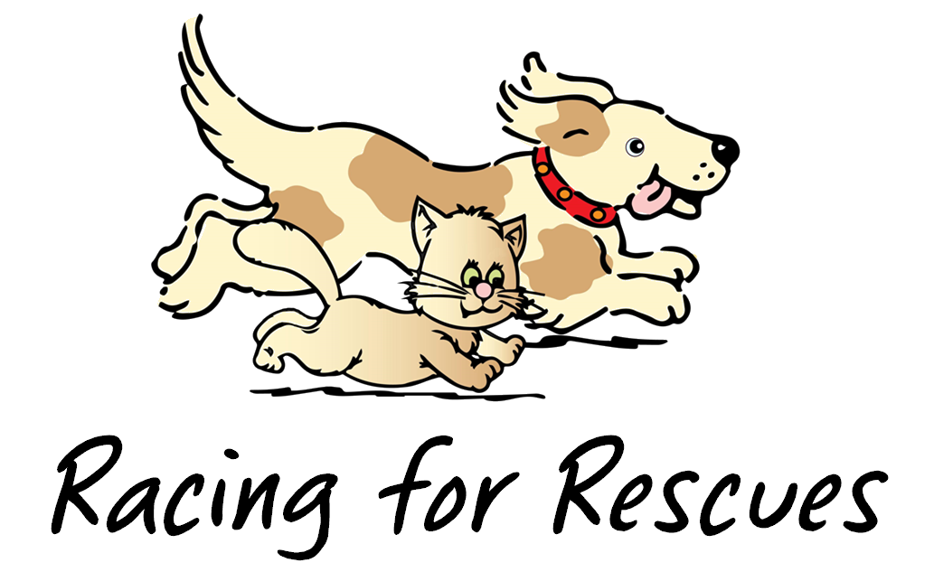
Second Chance Pet Adoptions’ Racing for Rescues 5K/Walk
Sunday, May 7, 2023 | 8:30 – 11:30 a.m. | C.M. Herndon Park

Vendor Registration Form

Vendor Name:____________________________________________________________________________________
Type of Business: _________________________________________________________________________________
Contact Name: ___________________________________________________________________________________
Address: ________________________________________________________________________________________
City: ___________________________________________ State: _____________ Zip: _________________________
Phone: _____________________________________ Phone type (cell, work, home): _________________________
Email: _____________________________________ Web address: _________________________________________

Vendor Fee - $50, which includes:
- The opportunity to place your business’ promotional materials/products in participants’ “doggy” bags (must be delivered to Second Chance by Friday, April 28, 2023; open Monday – Friday 11:00 a.m. – 5:00 p.m.).
- 10’ x 10’ booth space at event for company information, distribution of promotional materials, and/or product sales (no alcohol allowed). Please note: vendor space does not include tables, chairs, or tent. Please plan on bringing these items. There is no access to electricity at this event.

Payment Methods:
- Enclosed is my $50.00 check, made payable to Second Chance Pet Adoptions.
- I will mail a $50.00 check, made payable to Second Chance, likely to arrive by date: ________________.
- I would like to pay by credit card. Please charge my card $50.00: must be no later than April 28
□ Visa □ MasterCard □ Discover □ American Express
Name on Credit Card: ___________________________________________________
Credit Card Number: ___________________________________________________
Expiration Date: ______/_______ CVV code: ________

Please return form ASAP – deadline is Wednesday, April 22, 2023!
- Mail to Second Chance Pet Adoptions, 6003 Chapel Hill Road, Suite 133, Raleigh, NC 27607, or
- Email to Rachel@SecondChanceNC.org.

Questions? Contact Rachel Cronmiller at Rachel@SecondChanceNC.org or (337) 580-4559.

This event is rain or shine. In the event of lightning or heavy winds, the event will be cancelled. Please check your email the morning of the event if you are unsure about weather conditions. If you do not have an email from us, the event is proceeding as scheduled. Vendor fees for day-of no-shows are non-refundable.

